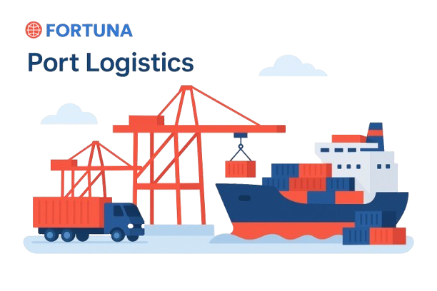



Website: www.fortunaglobalsupplychain.com
E-mail: info@fortunaglobalsupplychain.com

🏢 Company Overview

Fortuna Global Supply Chain Systems is a next-generation enterprise technology company revolutionizing the global logistics and supply chain landscape.
With a vision to create intelligent, transparent, and connected ecosystems, Fortuna blends innovation, data intelligence, and automation to help businesses achieve supply chain excellence.
Established with the belief that efficiency is the new currency, Fortuna empowers organizations to manage operations smarter — from demand planning to last-mile delivery — through real-time insights and seamless digital integration.
We are not just a technology provider; we are partners in transformation — driving global supply chain optimization with precision, performance, and predictive intelligence.

FORTUNA GLOBAL SUPPLY CHAIN SYSTEMS

“The Future of Enterprise Intelligence.”

Fortuna Connect Hub- “EDI → API Modernization & Integration Hub”

Fortuna Connect Hub is a cloud-based integration and modernization platform that connects every component of the digital supply chain — from legacy EDI systems to modern API ecosystems. It serves as the central data exchange hub across suppliers, logistics partners, warehouses, and enterprise systems, ensuring real-time, secure, and reliable data flow between all modules of the Fortuna Supply Chain Suite.
It is like a nervous system that connects all Fortuna products (SIMS, TMS, DemandSense, YardSync, PlanCopilot, etc.) and also external systems (ERPs, CRMs, supplier networks, etc.) through modern API-driven connectivity. ConnectHub transforms disconnected systems into a single, orchestrated digital network, enabling seamless communication, automated workflows, and instant visibility across your enterprise and partner ecosystem.

It acts as the data and process backbone of Fortuna’s ecosystem — integrating:
- ERP, CRM, WMS, and TMS systems
- Supplier, distributor, and logistics networks
- IoT device feeds and AI-driven platforms.

⚙️ 2. System Architecture
Fortuna Connect-Hub operates on the Integration Cloud Framework, composed of five intelligent layers:
1. Connectivity Layer - | EDI translators, RESTful APIs, and secure communication protocols.

2. Integration Orchestration Layer - | Real-time workflow and data transformation engine.

3. Intelligence Layer - | AI-powered data validation, mapping, and error correction.

4. Cloud Infrastructure Layer - | Multi-tenant SaaS model hosted on AWS/Azure for scalability.

5. Monitoring & Security Layer - | End-to-end visibility, analytics, and encryption compliance.
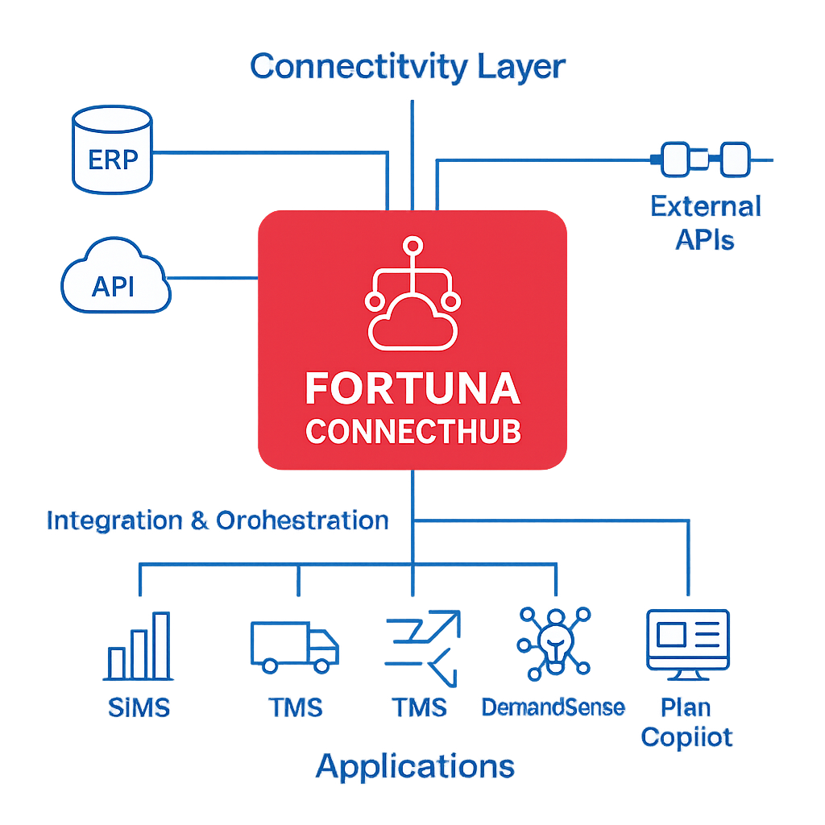

🔗 1: EDI → API Modernization Engine

Product Modules, Sub-Modules & Operational Functionality

📚 Submodules:
- Legacy EDI Translator – Converts X12, EDIFACT, and TRADACOMS messages into structured APIs.
- API Gateway Manager – Centralized control for API publishing, versioning, and lifecycle management.
- Mapping & Transformation Engine – Converts data between EDI, XML, JSON, and CSV.
- Event-Driven Integration Engine – Triggers actions based on real-time API events.

⚙️ Operational Functionality:
- Enables instant migration from traditional EDI to RESTful APIs.
- Auto-maps data schemas for interoperability across platforms.
- Facilitates hybrid workflows (EDI + API) during transition periods.
- Reduces manual intervention in data transformation processes.

Product Modules, Sub-Modules & Operational Functionality

📚 Submodules:
- Historical Data Modelling – Learns from past sales, promotions, and seasonal behaviour.
- AI Forecast Generator – Produces short-term, mid-term, and long-term forecasts.
- External Signal Integration – Considers weather, events, and market indexes.
- Forecast Accuracy Tracker – Monitors prediction reliability using MAPE & RMSE.

⚙️ Operational Functionality:
- Automatically collects and cleans data from ERP/POS systems.
- Generates rolling forecasts updated daily or weekly.
- Uses deep learning algorithms to detect new demand trends.
- Provides scenario simulations (“what-if” analysis).

🌐 2: Enterprise Application Integration (EAI)

📚 Submodules:
- ERP Integration Framework – Connects SAP, Oracle, Tally, and Microsoft Dynamics.
- CRM & SCM Connector Suite – Salesforce, Zoho, HubSpot, and Fortuna products.
- Database Sync Engine – Bi-directional data synchronization.
- Workflow Automation Hub – Links business events between systems (e.g., PO → Invoice → Shipment).

⚙️ Operational Functionality:
- Real-time integration between enterprise systems and partners.
- Reduces latency in cross-system communication.
- Automates workflow handoffs (e.g., purchase order → supplier confirmation → logistics dispatch).
- Provides 360° visibility of all integration activities.

🚀 3: Integration Orchestration & Automation

📚 Submodules:
- Process Builder Studio – Visual interface for designing data flows and automation rules.
- API Event Trigger Engine – Executes workflows upon data events or thresholds.
- AI-based Exception Manager – Detects and resolves integration failures automatically.
- Scheduler & Job Orchestrator – Handles recurring batch or time-based data exchanges.
⚙️ Operational Functionality:
- Enables end-to-end process orchestration across cloud and on-premise systems.
- Eliminates manual delays through automated task execution.
- Predicts integration failures using anomaly detection models.
- Increases business process agility through intelligent automation.

🌐 4: AI-Powered Data Mapping & Validation

📚 Submodules:
- Smart Mapping Engine – Learns field relationships between disparate systems.
- Semantic Analyzer – Identifies and fixes data inconsistencies automatically.
- Data Cleansing Engine – Removes duplicates, validates syntax, and ensures data quality.
- AI Data Reconciliation – Compares data flows to detect mismatched or missing entries.

⚙️ Operational Functionality:
- Uses AI to learn and adapt data relationships between trading partners.
- Improves data accuracy and transaction success rates.
- Provides audit logs and correction suggestions for users.
- Ensures enterprise-grade data consistency and integrity.

🔗 5: Partner Integration & Collaboration Hub

📚 Submodules:
- Partner On-boarding Portal – Self-service registration and integration testing.
- Multi-Tenant Partner Workspace – Separate dashboards for each supplier or partner.
- Real-Time Collaboration Feed – Shared communication and document exchange.
- Performance KPI Tracker – Monitors data exchange efficiency per partner.

⚙️ Operational Functionality:
- Simplifies partner on boarding through guided templates.
- Enables suppliers and logistics partners to monitor transactions in real time.
- Tracks message success/failure rates for transparency.
- Reduces integration time for new partner on boarding by up to 60%.

🛡️ 6: Security, Compliance & Monitoring

📚 Submodules:
- API Access Control Engine – Role-based authentication and access rights.
- Audit Trail & Log Management – Complete traceability for every transaction.
- Compliance Framework – Ensures adherence to GDPR, ISO 27001, SOC 2, and other standards.
- Monitoring & Alert Centre – Real-time API usage analytics and anomaly detection.

⚙️ Operational Functionality:
- Secures every data transaction through encryption and token-based access.
- Logs and monitors every API call for compliance visibility.
- Alerts administrators for unauthorized access or API failures.
- Provides compliance dashboards for audits and reports.

☁️ Module 7: Cloud Integration & Deployment Framework

📚 Submodules:
- Hybrid Cloud Connector – Supports on premise and cloud-based integrations.
- Kubernetes Deployment Engine – Containerized scaling for performance.
- Server less Function Bridge – Integrates server less compute (AWS Lambda / Azure Functions).
- Cloud Cost Optimizer – Monitors infrastructure utilization and costs.

⚙️ Operational Functionality:
- Deploys integration flows flexibly across multiple cloud environments.
- Enables auto scaling of workloads during high transaction volume.
- Reduces cloud-hosting costs with intelligent workload balancing.
- Ensures 99.9% uptime and SLA adherence.

📈 Functional Workflows

API Integration Cycle
  - Partner Data Submission (EDI/API)
  - Data Mapping & Validation
  - Workflow Trigger
  - Partner Notification / ERP Update
  - Success Confirmation & Analytics

B. Automated Order Processing
- Purchase Order (from ERP)
- EDI/API Transformation
- Supplier Confirmation
- Dispatch Notification (via TMS)
- Invoice Sync (to Finance)

Fortuna Connect Hub Advantages
Feature | Business Value
EDI → API Modernization | Enables real-time, scalable partner connectivity
AI-Driven Data Mapping | Reduces manual integration efforts by up to 70%
Real-Time Process Automation | Improves collaboration and efficiency
Secure Cloud Infrastructure | Guarantees compliance and data protection
Rapid Partner On boarding | Accelerates time-to-connect for new suppliers

Automotive & Industrial Manufacturing

🏭 Industries Served


FGSCM - supports the automotive sector with advanced logistics planning, vendor coordination, and predictive maintenance scheduling. From global parts movement to plant-level production support, our systems reduce lead times and enhance supply chain agility

Ports & Logistics
•


Fortuna supports the automotive sector with advanced logistics planning, vendor coordination, and predictive maintenance scheduling. From global parts movement to plant-level production support, our systems reduce lead times and enhance supply chain agility

Food & Beverage Distribution
•

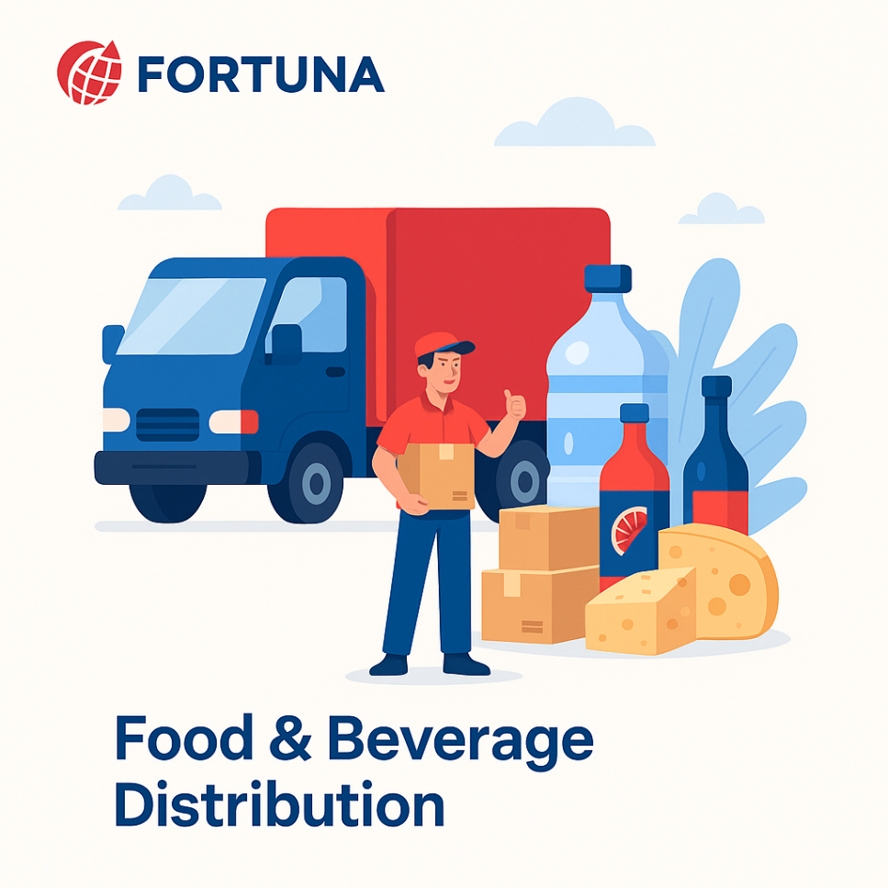
Freshness and safety are at the heart of Food & Beverage -supply chains. We enable end-to-end visibility with IoT-driven tracking, automated quality checks, and predictive demand planning—ensuring traceability from farm to fork.

Fashion & Retail Industry
•


With High seasonal demand & agile supply chain Planning, Fortuna will empowers retailers with faster replenishment & reduces stock outs

Pharma & Healthcare
•


Medical safety and regulatory compliance are non-negotiable. We provide automated solutions for cold chain logistics, product traceability, and compliance monitoring—ensuring life-saving medicines and healthcare products reach destinations safely and efficiently.

E-Commerce & Distributional Channels
•


In a fast-moving E-Com world, speed and efficiency are critical. Our platforms enable automated order management, demand forecasting, and last-mile delivery optimization—ensuring customers receive the right products, at the right time, every time.

🏛️ Corporate Identity


Headquarters: Visakhapatnam, Andhra Pradesh, India
Website: www.fortunaglobalsupplychain.com
Email: info@fortunaglobalsupplychain.com

